
a
Company
Logotype

Cone Beam Computed Tomography- Report



Porur Dental X-rays & CBCT

Patient Name : Mr. Raajesh Kanna | Date of Report : 12.08.2025
Age/ Gender : 27 years/ Male | Region of Interest : CBCT Sectional Maxilla
Referring doctor: Dr. Selva Ganesh | Indication : Bone density &Implant assessment
Clinical Notes: Nil
PATIENT INFORMATION

CBCT- Sectional Maxilla provided
CBCT – IMAGE DETAILS

RADIOGRAPHIC INTERPRETATION

- The maxillary alveolar ridge is present with normal trabecular pattern.
- In relation to 12, presence of hyperdense restorative material within the pulp canal extending upto the apical third of the root. The crown appears to be irregular and there is minimal PDL space widening along the palatal aspect. In the apical region, evidence of a linear, hyperdense structure measuring 2.33 mm in dimension suggestive of a possible foreign body.
- In relation to 14, presence of hyperdense restorative material within the pulp canal extending upto the apical third of the root.
- In relation to 11, 21, presence of hyperdense restorative material involving the crown in evident.
- Bone type in relation to 12 region is D2 (351 HU to 648.3 HU).

 | 12 region
Sub-Crestal (in mm) | 5.26
Mid- Crestal (in mm) | 4.3
Distance between the apical region of 12 and floor of the nasal cavity (in mm) | 22.33
IMPLANT ASSESSMENT

RADIOGRAPHIC IMPRESSION

- Root canal treated tooth: 12, 14
- Restored teeth: 11, 21

Kindly correlate with history and clinical findings


IMAGES FOR REFERENCE

RECONSTRUCTED PANORAMIC VIEW
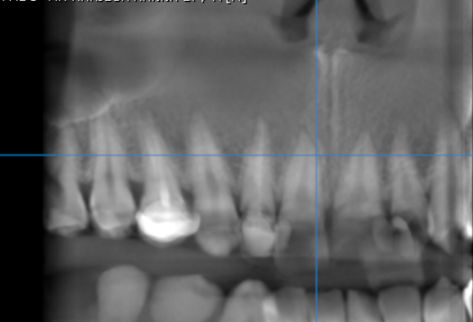

3-DIMENSIONAL VIEW

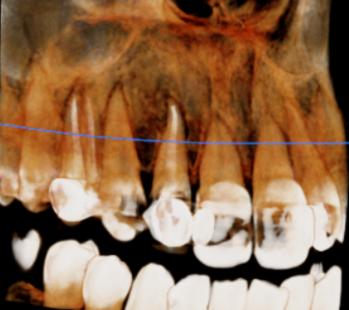

CROSS SECTIONAL VIEW

12 region | 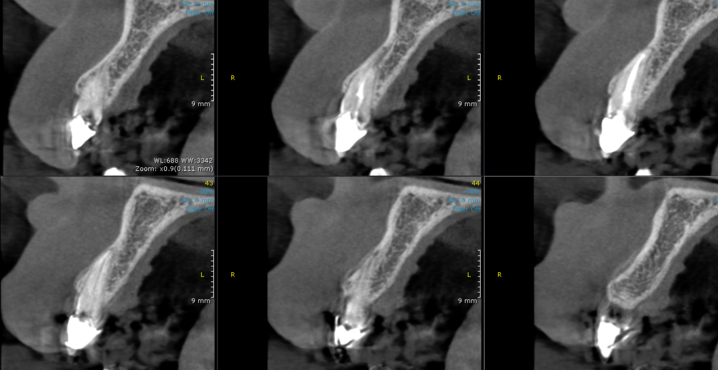  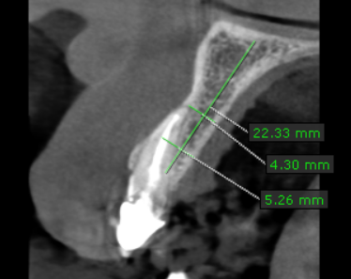  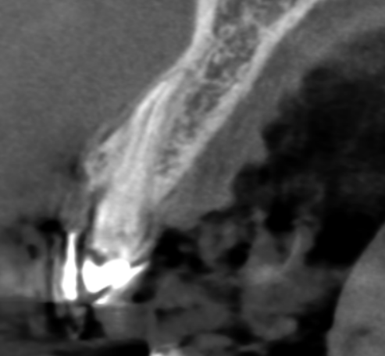

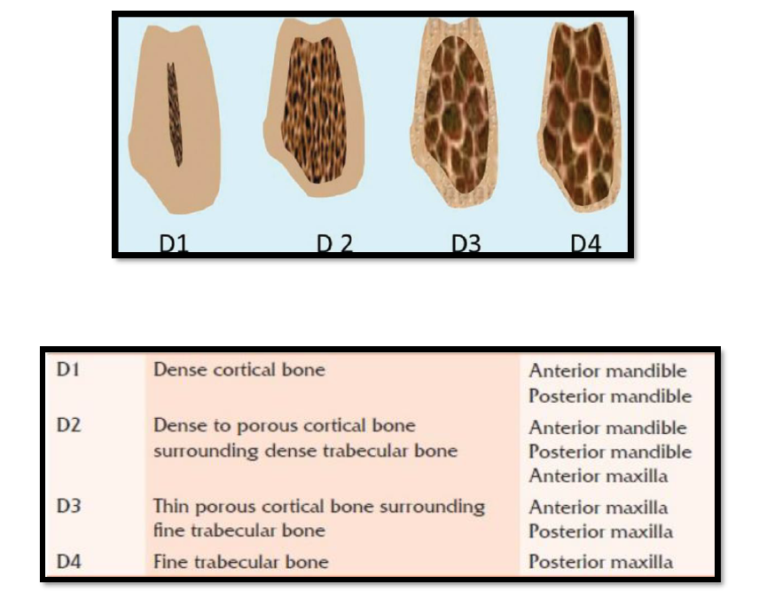
REFERENCE

**** End of report ****

